Q2)Describe about CAPWAP,explain the flow between AP and Controller

**CAPWAP** (Control And Provisioning of Wireless Access Points) – Standard protocol for communication between APs and WLC.

SplitMAC improves scalability and manageability compared to traditional **Autonomous APs** (where each AP works independently).

**CAPWAP** (Control And Provisioning of Wireless Access Points) is the key protocol that allows **Lightweight Access Points (APs)** and a **Wireless LAN Controller (WLC)** to communicate in a **SplitMAC Wi-Fi architecture**.

It is the **language** that dumb APs and the smart controller use to coordinate everything in a large Wi-Fi network.

## ****How CAPWAP Works?****

CAPWAP has **two main functions**:

1. **Control Messages** – For management (e.g., "Change your Wi-Fi channel").
2. **Data Forwarding** – For sending/receiving user traffic (e.g., video calls, downloads).

### ****1. CAPWAP Control Channel (Secure Management)****

* Used for sending **commands** from the WLC to APs.
* Examples:
  + "Switch to Channel 6, AP-05!"
  + "A new device just connected—authenticate it!"
  + "Reduce your power to avoid interference!"
* Runs over **UDP port 5246** (default).

### ****2. CAPWAP Data Channel (User Traffic)****

* Used to **tunnel** Wi-Fi user data (like web browsing, YouTube) back to the WLC.
* Runs over **UDP port 5247** (default).
* The WLC can inspect, prioritize, or filter traffic before sending it to the internet.

## ****Why CAPWAP is Important?****

✔ **Centralized Control** – All APs get commands from one WLC.  
✔ **Seamless Roaming** – Devices switch APs without dropping calls.  
✔ **Security** – Encrypted communication between AP and WLC.  
✔ **Flexibility** – APs can be far from the WLC (even over the internet).

## ****CAPWAP Modes: Local vs. Split MAC****

|  |  |  |
| --- | --- | --- |
| **Mode** | **Where Traffic Goes** | **Use Case** |
| **Local MAC** | Data stays at AP (only control goes to WLC) | Good for small offices |
| **Split MAC** | All traffic tunnels to WLC (full control) | Enterprise networks (most common) |

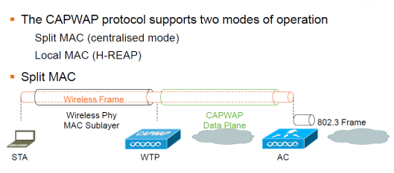

In Local MAC mode AP is doing all of the functions including the one done by WLC in Split MAC architecture:

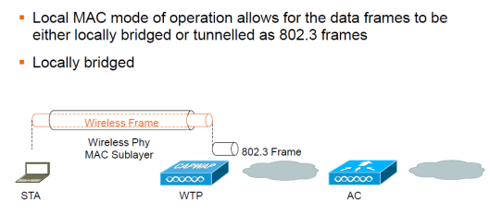

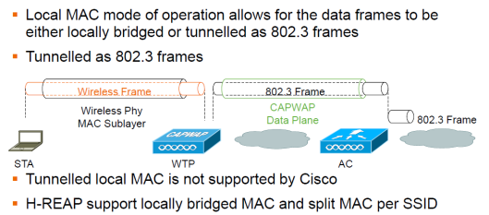

Below diagram shows the CAPWAP State machine where you need to understand this in order to determine from where you should start troubleshoot if something is not working:

